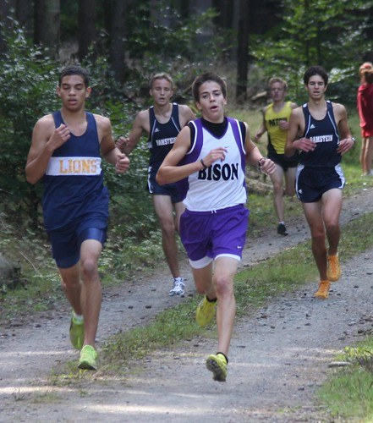
ASD-West Hatheway Middle School Sports 2020-Return to Play
ASD-West is proud to offer Middle School sports where possible for the 2020-21 school year provided that we remain in the Yellow Phase in regard to COVID-19. Middle School sports will potentially look much different as far as what we are able to offer this year. We believe it is important that we offer programs for students and schools that wish to participate.
Though Middle School sports are not governed by the NBIAA, ASD-W will be using their model in regard to implementing extracurricular sports where applicable. The NBIAA has set guidelines for return to play for High School sports with guidance from the Department of Health. This plan is based on COVID-19 Operational Plan Guide and respects Provincial protocols such as social distancing and disinfecting. This plan also follows protocols put in place by EECD with Appendix F for Physical Education and School Sports along with the Plans each Provincial Sport group has created.

ASD-W Hatheway Middle School Cross Country 2020
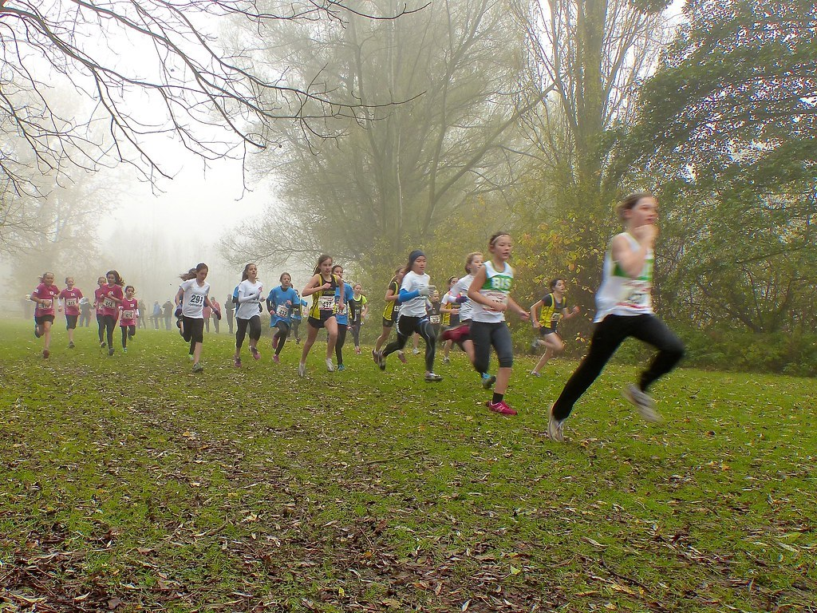
Cross country practices for Middle School can begin on Monday September 21st. 2-3 Races should occur at each individual school in each grade level and gender. Using those school-based races, each school will identify their top 3 runners per grade level per gender to compete in the district championships. The point system (same as last year) will be used to determine the top x-country school team and winner of the Banner.

Middle School Cross Country Schedule 2020 (Tentative)

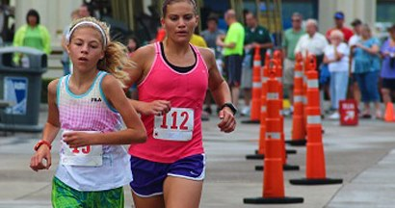
Sept 21st -Oct 16th schools will hold two- three school-based races to determine their district teams. Note that runners can only compete once every 5 days. This is outside of practice time.
Week of Oct 21st district finals will happen per grade level and gender. Schedule/Locations TBA

Cross Country Protocols

No in person registration, all registrations must be done prior to the race via email (district event)
All participants must sanitize their hands when entering the event and after the completion of their race. The host of the race will be responsible for having sanitizer present for participants.
No handing out of any awards of any type on site. All awards (including ribbons) must be sent to the school and distributed there.
Participants should come to the race area on their own just before the beginning of their race. They should also leave and return to their car immediately after they have finished their race.
Personal protective equipment should be used by all volunteers.
No high-fives, hugs, group photos or spitting.
Have any lines flow in one direction, in one way and out another.
Mark spacing for physical distancing where applicable. I.e. Create a blocked starting grid.
Ask that runners come prepared to run. There will be no access to changing facilities.

Roles and Responsibilities
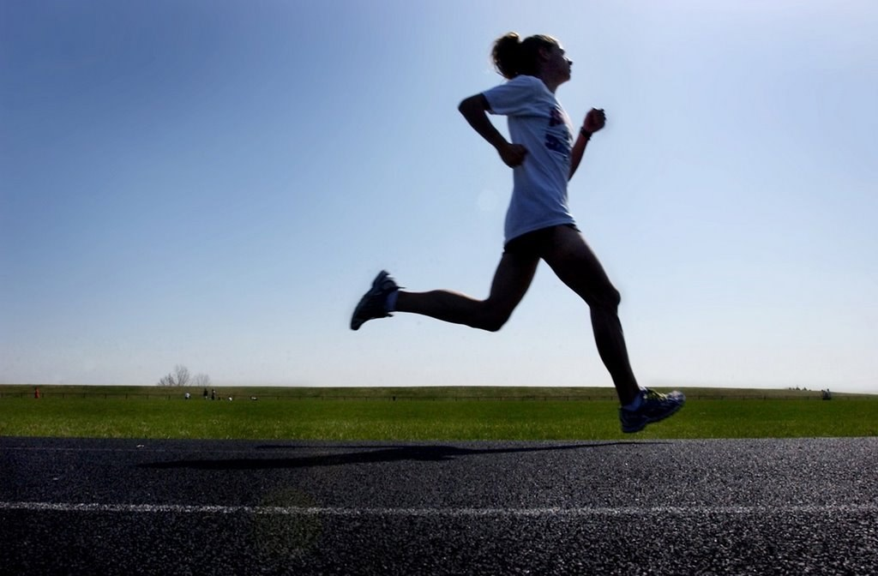
There must be a "Reception Manager" at the event to meet participants and coaches, take attendance and make sure that hands are sanitized. The name, phone number and time of everyone entering the event must be recorded and stored in a safe place for tracking purposes. For the district event students not registered cannot participate in the event. Coaches should make it known to the Reception Manager if any of their students that were registered but are not present at the event.
There should be several course volunteers on the course to keep runners on track and to remind runners of the social distancing expectation.
Course Marshal and Starter will be responsible for the start and finish of the races.
Timers will be needed for the finish as well as a Recorder.
Space should be marked off for participants to warm up in (stretching) while they wait for their start.
Ensure that equipment is disinfected prior to the race and after the races are completed.

Cross Country Race Rules
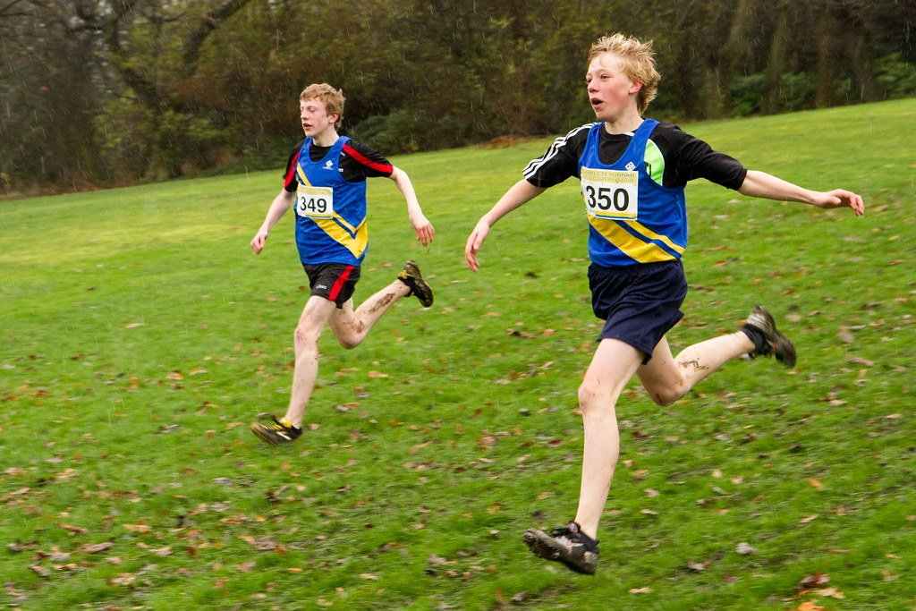
Option One: Race in timed heats of 5-6 racers at a time or as much as the start line will allow up to a max of 10 runners with a 2m social distance cube. This is to reduce on course interaction. Ensure that participants are aware of the time of their race and come for that time. It will be very important to set race times that give enough time to cycle one age/gender group out and another in. (30 minutes in between)
Option Two: Use staggered start times with a 20-30 second intervals that allow the recorder to record time minus the start interval. It will be very important to set race times that give enough time to cycle one age/gender group out and another in. (30 minutes in between)
Allow for physical distancing (2 M) in start corrals. Participants will be responsible to wear a mask upon entering the corral and until their race begins and wearing it after they finish until they leave.
No drafting permitted. Runners should verbally announce when passing someone by saying "passing". Any runner being passed should move to his or her left to let the other runner go by. A minimum of 2 M physical distance must be practiced by all participants and volunteers before, during and after the event. (Front to back and side to side; 2m cube)
The course should allow for physical distancing and must be a minimum of 2 M wide with no narrowing areas.
No two-way traffic area’s… should be a loop course.
On corners allow extra room for runners to distance.
Have volunteers on course to encourage physical distancing to runners on course and at corners. Have signage encouraging physical distancing.
Allocate more space for finish approach, line and finish chute. Finish approach should be as wide (or more) as your finish line.
Masks should be worn by participants and volunteers in the finish area.
Volunteer marshals in the finish line dispersal will remind finishers to keep moving while keeping their distance. Runners should put their mask back on once they have finished the race.
Post event gatherings of any kind should be discouraged. Ask participants to leave once they have finished their event.

Participant Reminders
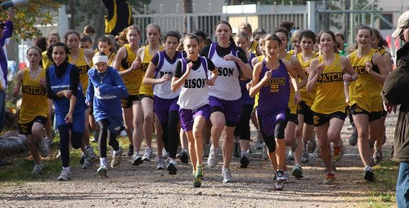
Remain 2 meters apart from others before, during and after participating in your race (no handshakes, high fives etc.). Reminder to announce when you are passing and if being passed to move to the left.
Arrive just before your race is to begin and leave immediately once your race is complete.
Avoid touching your face. Disinfect your hands before and after your race.
Do not share any food, water bottles, towels etc.
Come alone to the race start area, do not bring spectators. (Coaches can be present)

Covid-19 Symptoms
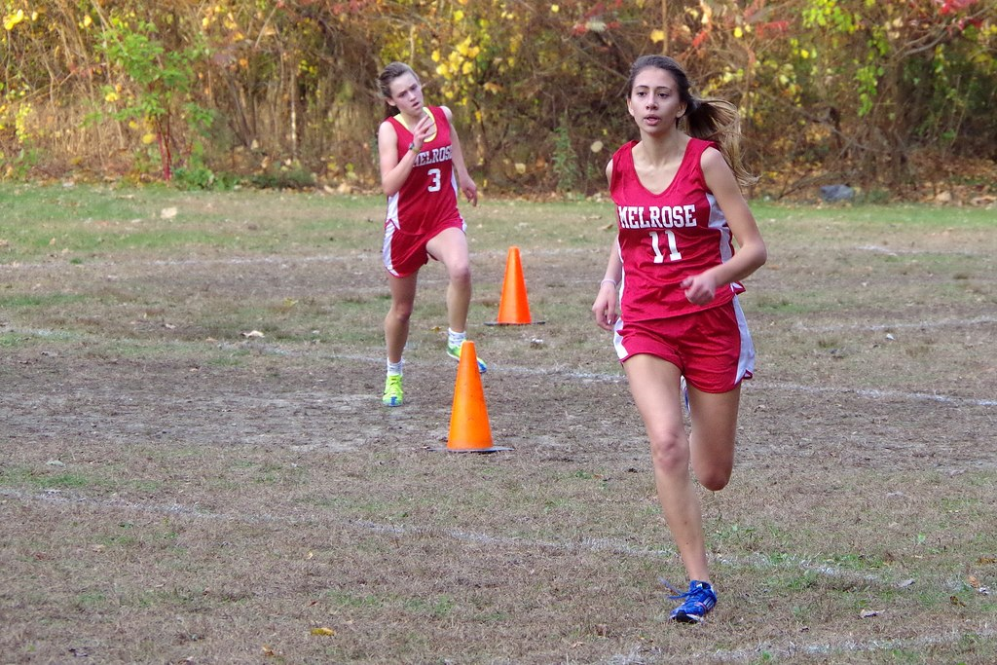
Participants should not race if they are exhibiting two or more of the following symptoms
•Fever above 38 degrees Celsius
•A new cough, or worsening chronic cough
•Sore throat
•Runny nose
•Headache
•A new onset of fatigue
•A new onset of muscle pain
•Diarrhea
•loss of sense of taste
•loss of sense of smell
•In children, purple markings on the fingers and toes
•Have been in contact with someone with COVID-19 in the last 14 days.
•Have travelled outside the province in the last 14 days
This Document was created in partnership with EECD, NBIAA, ANB and ASD-N
Middle School Badminton 2020 Season Plan (tentatively)
This Photo by Unknown Author is licensed under CC BY-SA
Badminton practices/tryouts for Middle School can begin on Monday October 26th. Tryouts and practices should occur at each individual school in each grade level and gender. Once teams are selected and practices have started, schools will play at the school level until November 6th. School may host/visit another school’s gendered grade level team to play as long as the travel and health protocols outlined below are followed beginning the week of November 9th. These matches will be scheduled by each individual school. District Championships will occur week tentatively in December and will be discussed on a TEAMS call at a later date.
Badminton Protocols
No in person registration, all registrations must be done prior to the match via email (district event)
All participants must sanitize their hands when entering the event and after the completion of their practice/match. Teams will be responsible for having sanitizer present for participants at home and while visiting another school.
No handing out of any awards of any type on site.
No spectators permitted at any event, coaches’, managers, athletic directors and players only.
Players should come to the facilities ready to play and only 5-10 minutes before practice/tryouts and games. They should also leave in a timely fashion once the activity has concluded.
Personal protective equipment should be used by all volunteers.
No high-fives, hugs, group photos or spitting.
Have any lines flow in one direction, in one way and out another.
Mark spacing for physical distancing where applicable. I.e. Seating and spacing for players who are in no-playing areas.
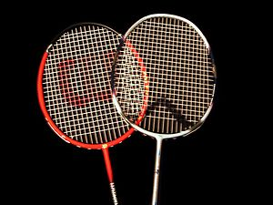
This Photo by Unknown is licensed under CC BY Author -SA
Each Badminton team will require to have a Manager to take attendance and ensure sanitization occurs upon entry and exit of facilities
Players
Before playing, prepare yourself:
- Wash your hands with soap and water for at least 20 second before going on court or with
disinfectant
- Bring hand sanitizer or use the school designated materials
- Don’t share your equipment with your playing partner. Your own equipment is highly recommended, or school should assign equipment to players for the duration or the season.
- Make sure you have enough water before leaving the house to avoid having to touch a tap or water fountain
- Wear a mask when entering and exiting the facility and when social distancing cannot be maintained; you can remove it properly when playing (https://www2.gnb.ca/content/dam/gnb/Departments/h-s/pdf/MASK.pdf)
- If you cough or sneeze, do so in a tissue or in your sleeve
- Avoid touching door handles, benches and all other objects where the virus could survive. If you touch something, make sure to wash your hands and disinfect the surface you have touched
Clubs and Coaches
Organizing your badminton club/school team:
- You will have to attach school based operational badminton season plan to your school operational plan.
- It is important to have a hard copy summary of your plan with you
- This plan is only applicable in the ‘’Yellow phase’’ of the province’s re-opening plan
- Communicate all hygiene measure in advance to all players/parents
- No parents are allowed in the gym; parents will drop their kids at the facility and will wait for them outside when the practice is over
- Non-playing areas must be arranged to accommodate physical distancing guidelines.
- Encourage players to respect social distancing of 2 meters when possible. If you can’t accommodate physical distancing, wear a mask; you can remove it properly when playing (https://www2.gnb.ca/content/dam/gnb/Departments/h-s/pdf/MASK.pdf)
- Have hand sanitizers available for the players however each player should be encouraged to have their own personal hand sanitizer.
- Keep indoor gatherings with physical distancing at a gender/grade level group for tryout/practice or game play. IE: Grade 6 girl night then a grade 6 boys’ night or stagger times so that there is a half hour in between groups with coaches wiping down the high touch surfaces.
- Record keeping for participants is required to facilitate contact tracing. IE: Attendance includes name, number and time in facility.
- Please only use the washroom if necessary and be sure to have your face mask on when entering as physical distancing may be difficult inside
- Tryout sessions are to have no more than 20 participants plus coach at one time in one gymnasium and should be kept to gender/grade level. If you have more than 20 sign up for tryouts you will need to make more sessions.
- Please cap team numbers to 12. You can have more than one grade level team just make sure they are designated Team grade girls 6 A and grade 6 girls B… and that they have different practice and playing times.

Coaching staff
- The coaching staff will have to ensure all distancing and hygiene protocols are followed.
• Practice physical distancing of 2 meters between yourself and any players, coaches, or staff. If that distance is not possible, coaches have to wear a face mask. (https://www2.gnb.ca/content/dam/gnb/Departments/h-s/pdf/MASK.pdf)
• Participants should come changed and prepared to play to reduce the need for change rooms. The only changing required upon arrival should be your outdoor shoes with your indoor shoes.
• Coaches and participants must wash hands or sanitize inside the entrance doors of the facility (before entering the gym) and before leaving the facility
• Arrive and leave as close to the scheduled times as possible to reduce your time at the facility
• For every practice, the coach/volunteer will be at the door taking attendance of everyone entering the facility. The coach/volunteer must keep the record of every practice in a safe place and must be ready to provide that list if asked by Public Health.
• To encourage social distancing, there will be a maximum of 4 players per court. • Players should avoid touching their face with their hands
• Coaches/volunteers must wear a face mask whenever coming within 6 feet of any players

Game Play
- Players should not change ends between games/matches
- Singles and Doubles will be played
- Players/coaches/volunteers are to be given designated shuttles at the beginning of the practice or games that are specifically identifiable (ex.: number, color or designated marking on the cork) from all other player/coaches/volunteer’s shuttles.
- Coaches/volunteers will keep record of the designated shuttle number or color for every player/coach/volunteer must be kept every practice.
- Designated Shuttles can only be physically handled or touched by the person that has been assigned to them.
- If someone needs to move a shuttle that has not been designated to them then they must use their racquet to move the shuttle.
- Shuttles that have not been designated to a person must not be used.
- Players will use their designated shuttles for warm-up, drills and matches.
- Players have to serve with their own shuttle
- When a rally ends and the shuttle lands on the receiving team’s side of the court the shuttle must be pushed back to the person who just served by using only their racquet to move the shuttle. The server will then either continue play or place his or her shuttle on the side of the court off the field of play. This shuttle will remain out of play until it is their turn to serve again.
- If at any point another player is to be assigned a tube of shuttles or shuttle previously assigned to another player, the shuttles must be disinfected prior to the reassignment of tubes/shuttles. If disinfecting is not possible then the shuttles must remain out of use for a minimum of 72 hours or 3 days between persons.
- If a coach/player or volunteer touches a shuttle not designated to them specifically then the shuttle must be disinfected or removed from play for 72 hours and the person who made contact with the shuttle must disinfect their hands immediately.
- At the end of practice, the designated shuttles will need to be stored in containers/tubes that have a matching number/color or marking identifiable with the shuttles that are inside.
- The outside of every container/tube containing designated shuttles will need to be disinfected at the end of each practice.
- Players should have their own personal hand sanitizer, face mask, face towel and water bottle court side. Players should be directed to disinfect their hands every time prior to grabbing their towel or water bottle.
- Nights of play/practice/tryouts needs to be designated pertaining to gender/grade level. This is to keep numbers low and to maintain good contact tracing data.
- Social Distancing, respiratory etiquette and hand and equipment sanitization is imperative to follow.
- Players are only allowed to compete every 5 days or more (as per NBIAA Regulations)

Participants should not compete or practice if they are exhibiting two or more of the following symptoms
•Fever above 38 degrees Celsius
•A new cough, or worsening chronic cough
•Sore throat
•Runny nose
•Headache
•A new onset of fatigue
•A new onset of muscle pain
•Diarrhea
•loss of sense of taste
•loss of sense of smell
•In children, purple markings on the fingers and toes
•Have been in contact with someone with COVID-19 in the last 14 days.
•Have travelled outside the province in the last 14 days
This document is adapted from Badminton NB and is referenced to Appendix F and NBIAA return to school documents.

